IMM 120 Syllabus

# Contact

Chris Hallberg

[crhallberg@gmail.com](mailto:crhallberg@gmail.com)

Office: Adjunct Office (Art History Lab [top of the stairs to the right])

Office Hours: 11am until Class every Monday. Contact to schedule an online session.

# Materials

No textbook

Online editor for p5.js: <https://editor.p5js.org>

p5.js Reference: <https://p5js.org/reference>

# Schedule

|  |  |
| --- | --- |
| September 4 | Intro and Syllabus |
| September 10 | Drawing on a Screen |
| September 17 | Variables, Conditionals, Motion |
| September 24 | Events and Interactivity, Collision Detection |
| October 1 | Media (Images and Sound) |
| October 8 | Networking |
| *October 15* | *Fall Break* |
| October 22 | Midterm Project |
| October 29 |
| November 5 | Loops |
| November 12 | Arrays / Lists |
| November 19 | *Flex* |
| November 26 | *Final Project Period* |
| December 3 |
| *Final: December 17* |

# Goal of this Class

The goal of this class is empowering students to create interactive media. A major part of this class is to teach “programming literacy”: the ability to read and write programs. By the end of this semester, you should be able to break down projects and problems into programmable chunks, communicate ideas in an algorithmic manner, and using code to bring your projects to life.

This class will also cover topics found in many environments that allow for the creation of interactive media: persistent storage, loading and using of media, pixel manipulation, event-driven interaction, network-based interactions, etc. These concepts will be taught through use of Javascript and an artistic library called p5.js.

# Grading Policy

I expect you to regularly demonstrate understanding of topics covered in class and how to apply them. Assignments need not follow the letter of the order if they demonstrate mastery of the targeted technologies and have comparable or greater complexity. Majors projects will be based off original ideas. This is to encourage play and experimentation.

Assignments that demonstrate appropriate effort but do not run or do not meet criteria will be returned with notes for improvement and an appropriate extension. Extensions without penalty will be given for sudden situations and in-progress assignments that need a little more time.

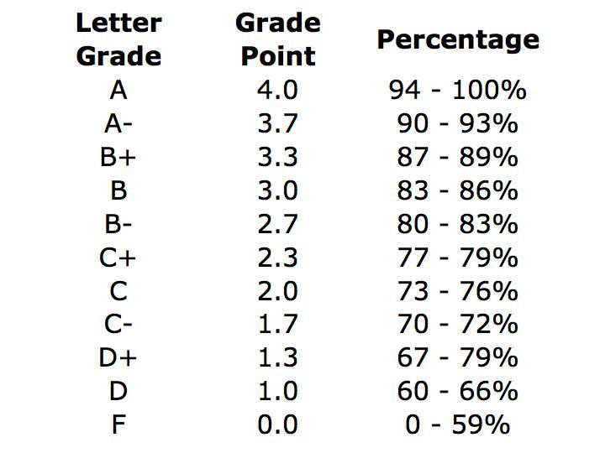

# Fine Print

[Academic](http://policies.tcnj.edu/policies/digest.php?docId=7642) [Integrity](http://policies.tcnj.edu/policies/digest.php?docId=9136)

* Please do not plagiarize.
* Share knowledge with each other, recent learners are often the best teachers. Don’t just copy each other’s code, you won’t learn that way. Ask them to explain it to you.
* Nobody codes in a vacuum. Code solutions borrowed from other sources may be used but must comprise a minor part of the overall functionality of your code. All borrowed code must be commented by you to demonstrate understanding of what is happening.
* If you’re not sure, please ask.

[Absence and Attendance](http://policies.tcnj.edu/policies/digest.php?docId=9134)

* Missing more than three classes is going to start to impact your grade.

[Final Examination-Evaluation-Reading Days](http://policies.tcnj.edu/policies/digest.php?docId=9136)

* We must have a final something
* Must count for 15% - 50% of your final grade, currently 35%

[Americans with Disabilities Act](http://policies.tcnj.edu/policies/digest.php?docId=8082) (ADA)

* If you’re registered with Office of Differing Abilities Services, please bring it to my attention to discuss any necessary accommodations.